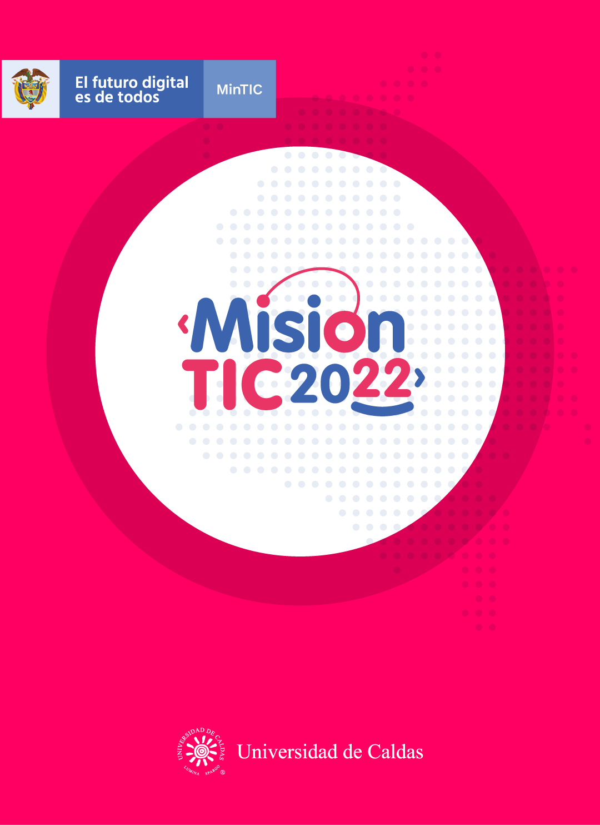

**CYCLE 2 – SESSION 2**

**WORKSHEETS**

**Object-Oriented Paradigm: objects and attributes**

**Worksheet 2.1**

**VOCABULARY : Write down the meaning of each word.**

**Deck:Baraja de cartas**

**Worth: Valor**

**Face:Cara,Afrontar,Enfrentar**

**Ace: Uno u once**

**Jack:Tomacorrientes**

**Queen: Reina**

**King:Rey**

**Hand:Mano**

**Shuffle:Mezclar las cartas**

**Deal/Dealt:Repartir las cartas ,acuerdo o trato,turno**

**Win:Ganar**

**Lose:Perder**

**Draw/Drawn: Tomar extraer una carta,dibujar**

**Worksheet 2.2**

Read a description of the simplified Blackjack and practice the vocabulary you learned before.

The game is played by two players with a deck of 52 cards. Cards are worth their face value, except for the ace, which is worth 1 or 11 points (the player can decide). Jack, queen, and king are worth 10 points each. A hand's value is the sum of the values of the cards.

The player will play against the computer (an AI system called Alana). The goal of the game is to have the hand with the highest value, up to a value of 21.

The cards will be shuffled and the player and Alana will be dealt two cards each. The player's cards will be shown face up. One of Alana's cards will be displayed face up, and the other will be face down.

*Figure 1: Example of an initial deal*

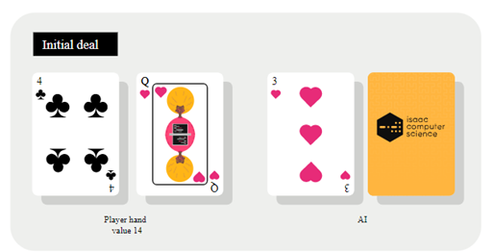

If either the player or Alana has an ace and a ten, or an ace and a jack/queen/king (hand with a value of 21), they immediately win the round. If both players have an initial hand with a value of 21, the game is drawn.

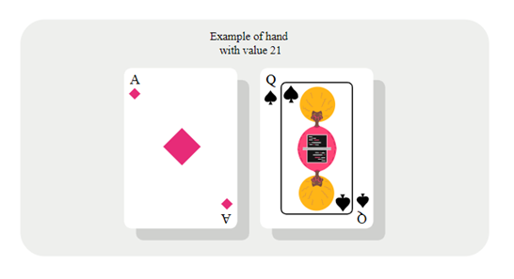

*Figure 2: Example of a hand with a value of 21*

Otherwise, the player can take one of two actions: they can 'stick' (which means that they don't want any more cards) or they can 'draw' (which means that they will receive another card). If the value of the player's hand exceeds 21, the hand is 'bust', and the player loses the game.

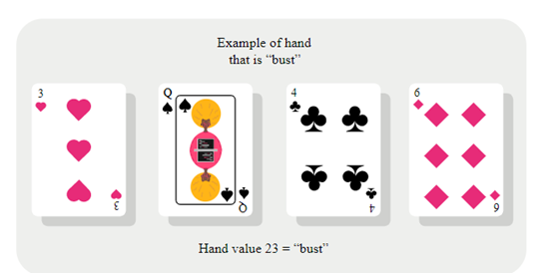

*Figure 3: Example of a "bust" hand*

Once the player has decided to 'stick', Alana's face-down card will be revealed, and Alana can draw more cards, one at a time. Alana will 'decide' each time whether to stick or take another card. If the hand's value exceeds 21, the hand is 'bust', and Alana loses the game.

If both hands have a value of less than 21, the hand with the highest value wins the game.

A win is worth 2 points and a draw is worth 1 point. The first player to reach 20 points is the overall winner.

**Worksheet 2.3**

Read the explanation of “Objects” and “Attributes” in OOP approach. Then you have to relate those concepts to the game, and think in some examples of objects and attributes as you read: you can highlight the potential objects in the game description, please write some ideas of attributes for cards and for the player. After you can share your ideas with the class.

**OOP design: objects**

The first step in OOP design is to identify objects. In the real world, objects are part of our everyday lives. Some of these objects are 'things', e.g. a pen, and some are more complex to understand, e.g. bank account.

To help identify the objects in the card game, consider the first two paragraphs of the game description. Highlight the potential objects in this description:

The game is played by two players with a deck of 52 cards. Cards are worth their face value, except for the ace, which is worth 1 or 11 points (the player can decide). Jack, queen, and king are worth 10 points each. A hand's value is the sum of the values of the cards.

The player will play against the computer (an AI system called Alana). The goal of the game is to have the hand with the highest value, up to a value of 21.

At the moment, you just select the most important things in the system to model. If in doubt, you should assume that anything that exists in the real world (relating to the problem domain), that has some specific meaning, will be an object.

**OOP design: attributes**

The next step of the design process is to identify the attributes of each object. Attributes are the characteristics that the objects have. Each attribute is a data item that helps

define or describe the object. In the real life, things can have many different attributes, but here we will only consider the attributes that are relevant for the game.

In the card game, a playing card is an object. How would you describe it? A playing card has three important attributes:

1. It has a __value/worth___.
2. It has a _color____.
3. It has a __suit (symbol) / ex. heart,diamond____.

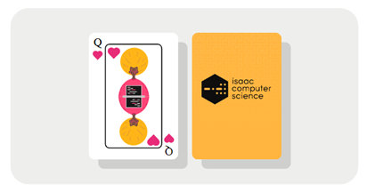

*Figure 5: A standard playing card*

A Player can have a lot of attributes, such as their age, hair color, and shoe size. However, you should only include the attributes that you need for the game. In this case, there are two attributes that a player will have in this game:

1. They have a ___name___.
2. They have a __turn score____.

Finally, consider a more complex object, the deck of cards. What are the attributes of a deck of cards? How would you describe it? It is just a collection of playing cards, so you can use an array to hold the collection.

1. It has 52 cards
2. Categories suits
3. Values
4. Colors
5. A shape
6. Material

|  |  |  |
| --- | --- | --- |
| **Deck** | | |
| **Attribute** | **Data type** | **Example** |
| Cards | Array [52] | [card 1, card 2, ...] |

**Worksheet 2.4**

**Answer the following questions:**

1. Entiendo qué son los Objects en OOP.

Yes **😃** Maybe **😐** No **😟**

1. Entiendo qué son los Attributes en OOP.

Yes **😃** Maybe **😐** No **😟**

1. Entiendo cómo se hacen las conexiones entre el texto y el mundo real.

Yes **😃** Maybe **😐** No **😟**

1. Hacer conexiones entre el texto y el mundo real me ayuda a entender mejor el texto.

Yes **😃** Maybe **😐** No **😟**